Title of the Paper

Authors
Authors Contact Information

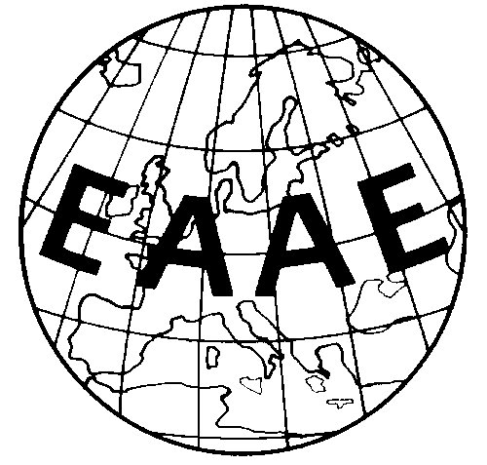

Paper prepared for presentation at the 165. EAAE Seminar ‘Agricultural Land Markets –
Recent Developments, Efficiency and Regulation’

Humboldt-Universität zu Berlin, Germany, April 4-5, 2019

Copyright 2019 by [authors]. All rights reserved. Readers may make verbatim copies of this document for non-commercial purposes by any means, provided that this copyright notice appears on all such copies.

Titel
Authors

Abstract (max. 100 words)

Keywords:
JEL Code:

